Heaven’s light is our guide



RAJSHAHI UNIVERSITY OF ENGINEERING & TECHNOLOGY
Department of Mechatronics Engineering

Lab Report
Experiment No.:02
Experiment Name: I/O Port programming for Atmega32 with Proteus Simulation

Submitted By: | Submitted To:
Samia Afsana  ID: 2008055  3rd Year , Odd Semester  Department of Mechatronics Engineering  Rajshahi University of Engineering & Technology, Rajshahi-6204. | Md Mehedi Hasan  Assistant Professor  Department of Mechatronics Engineering  Rajshahi University of Engineering & Technology, Rajshahi-6204.
Md. Sakib Hassan Chowdhury
Lecturer
Department of Mechatronics Engineering
Rajshahi University of Engineering & Technology, Rajshahi-6204.

Date of Experiment:20 March, 2024
Date of Submission: 29 March, 2024

MTE 3104
Microcontroller and Interfacing Sessional
Experiment No.: 02
Experiment Name: I/O Port programming for Atmega32 with Proteus Simulation.

Objectives:
- To understand the basics of interfacing input switches and output LEDs with an AVR microcontroller.
- To learn how to configure the microcontroller's I/O pins for input and output operations.
- To implement a simple logic to control the LED based on the state of two input switches.
- To gain practical experience in writing and uploading C code to an AVR microcontroller.

Theory:
In this experiment, using an AVR microcontroller, specifically the ATmega32, to interface two switches and an LED. The ATmega32 microcontroller is a popular choice due to its versatility and ease of use in embedded systems.
AVR Study: The Atmega32 is a popular 8-bit microcontroller from the AVR family manufactured by Atmel (now part of Microchip Technology). It features a rich set of peripherals and is widely used in embedded systems.
LED Blinking: LED blinking refers to the process of continuously turning an LED (Light Emitting Diode) and off in a repetitive pattern. It is a simple and common demonstration in electronics and microcontroller-based projects. [1]
Pulldown resistor: A pull-down resistor is a resistor connected between a signal line and ground in a digital circuit. It ensures that the wire is at a defined low logic level even when there are no active connections with other devices. The pull-down resistor holds the logic signal near to zero volts (0V) when no other active device is connected. It pulls the input voltage down to the ground to prevent an undefined state at the input. [2]

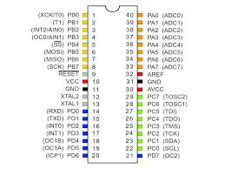
Fig.-1.1: Atmega32 Microcontroller
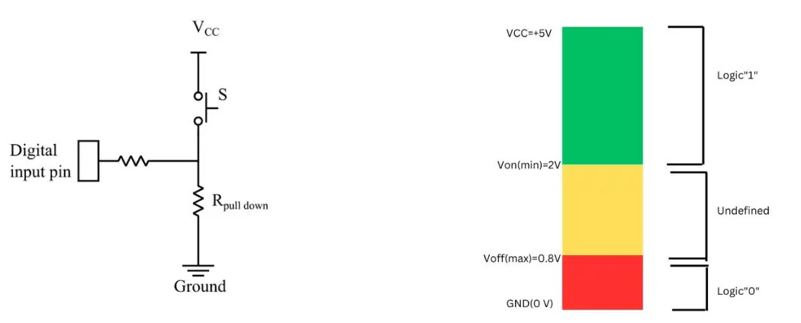
Fig.-1.2: Pulldown Resistor

Working Principle:
- The program starts by configuring two pins of PORTC (PC0 and PC1) as input pins using bitwise operations.
- Another pin of PORTD (PD0) is configured as an output pin to control the LED.
- Inside the main loop, the program continuously checks if both switches connected to PC0 and PC1 are pressed simultaneously.
- If both switches are pressed simultaneously, the LED connected to PD0 is turned on by setting the corresponding bit in the PORTD register.
- If either of the switches is not pressed, the LED is turned off by clearing the corresponding bit in the PORTD register.
- A small delay is added for debouncing to ensure smooth operation and to avoid rapid toggling of the LED state.

Required Components:
- Atmega32 Microcontroller
- Power
- LED-Green
- Wire
- Ground-(2)
- Resistor
- Switch-(2)

Code:

#include <avr/io.h>
#define F_CPU 8000000UL
#include <util/delay.h>

int main(void)
{
/* Replace with your application code */
DDRC &= ~(1 << PC0);
DDRC &= ~(1 << PC1);
DDRD |= (1 << PD0);

while (1)
{
if ((PINC & (1 << PC0)) && (PINC & (1 << PC1)))
{
PORTD |= (1 << PD0);
}
else
{
PORTD &= ~(1 << PD0);
}
_delay_ms(1000);
}
return 0;
}

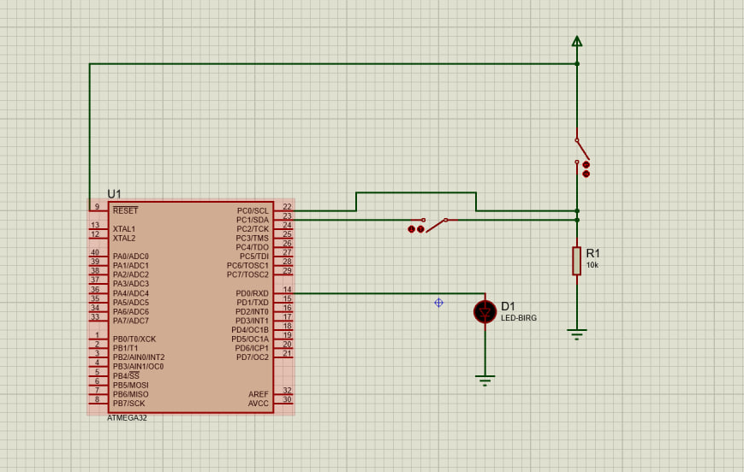
Fig-1.3: LED blinking in Proteus (Off phase)

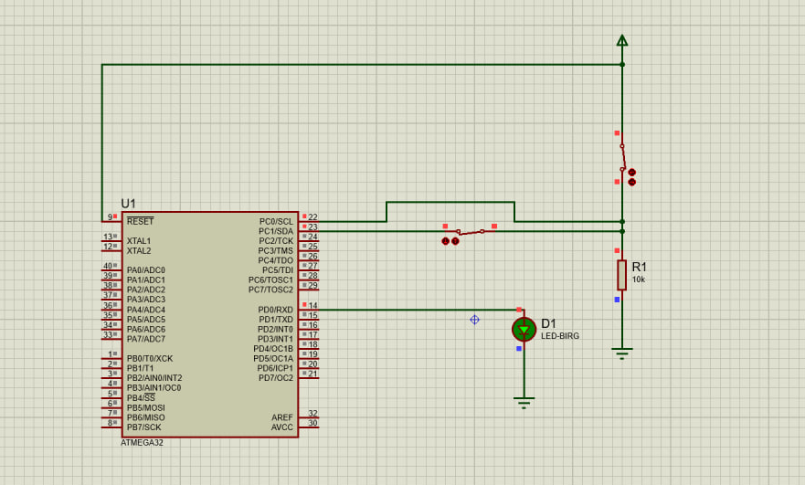
Fig.-1.4: LED blinking in Proteus (ON phase)

Discussion:
The experiment demonstrates how the Atmega32 microcontroller can control external devices such as LEDs using switches. The experiment offers the blinking of the LED when the two switches are ON simultaneously. Using switches, the blinking of LED can be controlled smoothly provided by this experiment. The experiment visualizes the practical representations of embedded systems.

Practical Uses:
- Home Automation: Switches attached to an AVR microcontroller enable users to easily customize and control lighting fixtures or other devices.
- Security systems: LEDs can be used to indicate the armed/disarmed status of a security system, while switches can be used to control various modes
- Industrial Automation: LEDs can indicate different states of machinery or processes.
- Traffic Control Systems: The microcontroller can manage these switches and LEDs to ensure smooth traffic flow and safety.

Conclusion:
Conclusively, the experiment successfully achieved the objective of controlling an LED based on the simultaneous press of two switches using an AVR microcontroller. Concepts like input/output pin configuration, bitwise operations, and conditional statements were reinforced through practical implementation. The program demonstrates the versatility and effectiveness of AVR microcontrollers in embedded systems applications.

References:
[1] https://www.google.com/search?client=firefox-b-d&q=LED+blinking
[2] https://www.google.com/search?client=firefox-b-d&q=pulldown+resistor
[3] Johnson, M. (2023, June 15). "Introduction to Atmega32 Microcontroller." Electronics Tutorials.

